**Drugs, what’s it all about?**

What are legal drugs?

* Legal drugs are drugs you can buy over the counter at a s______________ or pharmacy.
* These may have an age limit, like alcohol and t_________________ products.
* Examples include:
  + Paracetamol or C_________________
  + Hay fever medication

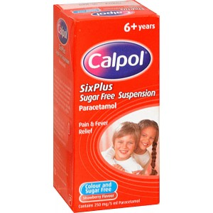

How to store and take legal and prescribed drugs

* **NEVER** take any kind of drug without your parents or a doctor telling you to
* **ALWAYS** store any drug well out of the way of children
* **NEVER** take any drug that has been prescribed for someone else (Even if you have the same symptoms)
* **REMEMBER** you can be allergic to drugs, so take care!

What are prescription drugs?

* These are drugs that H_____ to be prescribed by your doctor.
* You cannot buy them at the shop or p_____________
* These are on prescription as they are usually v______ strong and can make you i_______ if you don’t take them correctly.
* Always read the leaflet inside the box before taking any medicine



Illegal drugs

* These are drugs that are illegal to carry, t___________ or sell.
* They are usually sold by “Drug dealers” who are c_________. They often support other crime (Like terrorism)
* They are illegal as they cause some v________ bad effects upon your body, and can even k___________ you!!
* Illegal drugs are not regulated and can be dangerous and d____________ as they are not prepared safely.

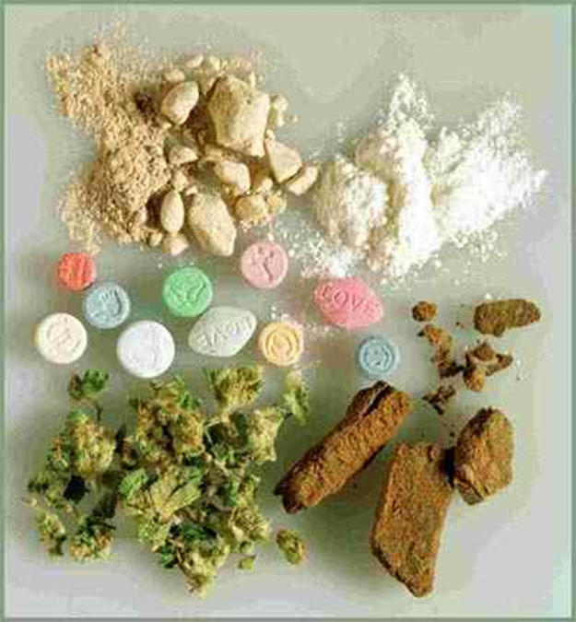

Although drugs have many “Street names”

Examples include:

* Marijuana or cannabis
* Cocaine
* Heroin
* Ecstasy
* LSD (Acid Tabs)