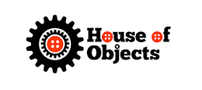
House of Objects Creative Recycling Centre
The House of Objects (Hobs) is located in the Rising Sun Country Park in North Tyneside.
It was created in 2007 as a creative recycling centre for schools, individuals and the wider community. At the core of its work is the belief that working creatively with reclaimed and found materials under the guidance of artists and educators enriches the development of all and particularly young people. Since 2007 Hobs has provided a warehouse of materials, donated by local businesses, which members (schools, youth groups, community groups, individuals and students) take for reclaiming, recycling and upcycling[1] and workshop areas staffed by experienced artists, educators and facilitators to run training sessions for teachers, education students, youth and play workers and others. They also run workshops for school groups, youth groups and young adults, and team building sessions for businesses and charity/not-for-profit groups.Shanklea Primary School works in partnership with this creative centre.

