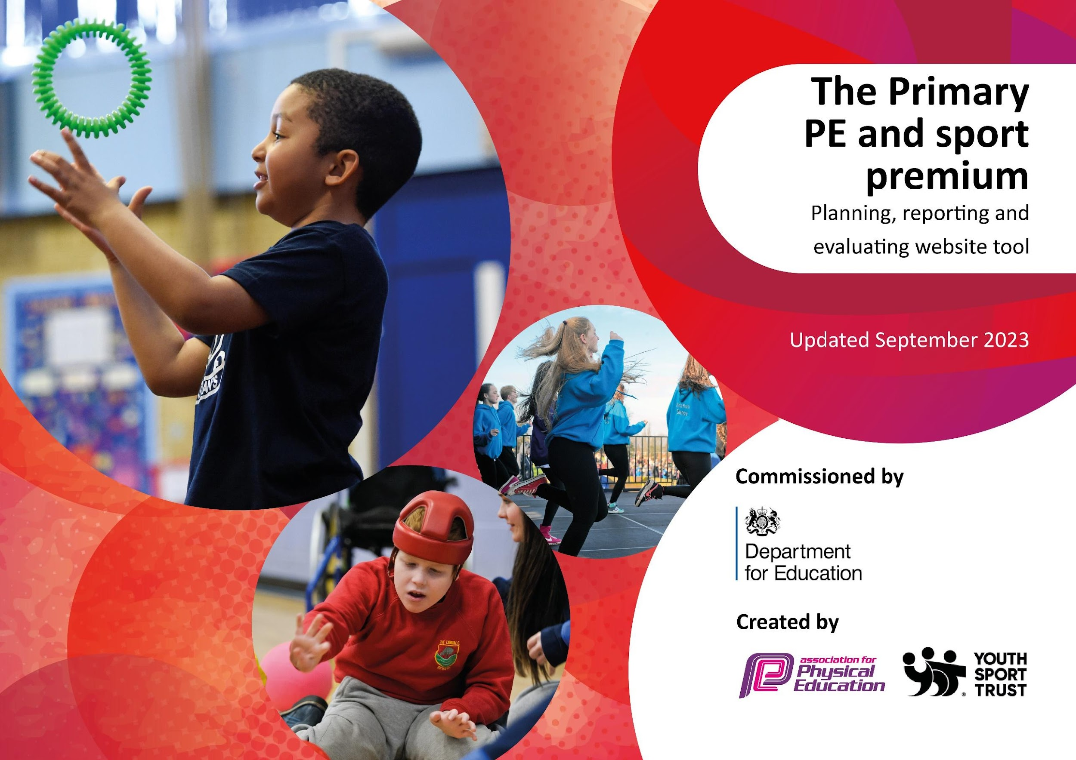

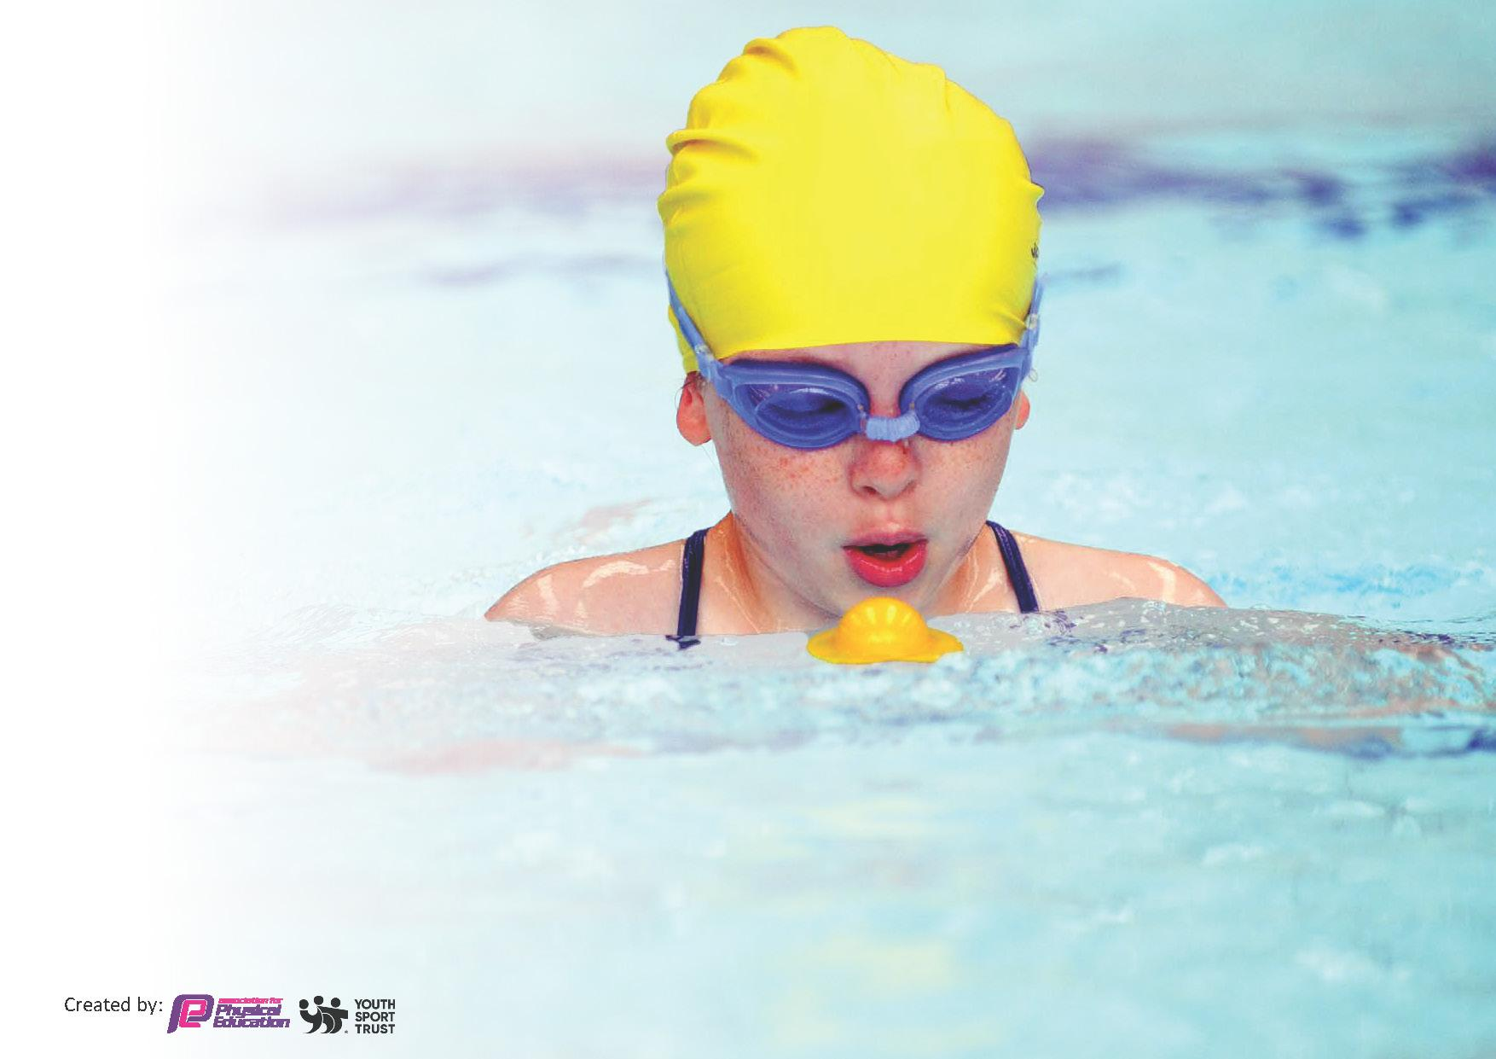
This template can be used for multiple purposes:
by:
- It enables schools to effectively plan their use of the Primary PE and sport premium
- It helps schools to meet the requirements (as set out in guidance) to publish information on their Primary PE and sport premium
- It will be an effective document to support Ofsted inspections enabling schools to evidence progress in Physical Education (PE) and evidence swimming attainment, which forms part of the PE National Curriculum. We would recommend schools consider
the Intent, Implementation and Impact of any spend, as examined within the Education Inspection Framework.

It is important that your grant is used effectively and based on school need.

Schools must use the funding to make additional and sustainable
improvements to the quality of the PE, School Sport and Physical Activity (PESSPA)
they offer. This means that you should use the Primary PE and sport premium to:

- Build capacity and capability within the school to ensure that improvements made now will benefit pupils joining the school in future years
- Develop or add to the PESSPA activities that your school already offers.

The Primary PE and sport premium should not be used to fund capital spend projects; the school’s core budget should fund these. Further detail on capital expenditure can be found in the updated Primary PE and sport premium guidance.

The Primary PE and sport premium guidance, outlines 5 key priorities that funding should be used towards. It is not
necessary that spending has to meet all the key priorities, you should select the priorities that you aim to use any funding towards.

Although completing this template is not a requirement for schools, schools are required to publish details of how they spend this funding. Schools must also outline what the impact this funding has had on pupils’ PE and sport participation and attainment and how any spending will be sustainable in the future. All funding must be spent by 31st July 2024.

The Department for Education has worked closely with the Association for Physical Education (afPE) and the Youth Sport Trust (YST) to develop this template and encourages schools to use it. This template is an effective way of meeting the reporting requirements of the Primary PE and sport premium.
Review of last year’s spend and key achievements (2023/2024)

We recommend you start by reflecting on the impact of current provision and reviewing your previous spend.

Activity/Action | Impact | Comments
Last year’s actions:  To ensure all children are participating in two hours a week of high quality PE by focusing on teacher training.  Key Indicator 1  By upskilling staff, we can ensure that all pupils’ will receive 2 hours of high quality physical education every week.  Key Indicator 1 and 3  Pupils will be developed in their physical, cognitive, social and emotional learning, therefore improving learning in PE and across the school.  Key Indicator 2  Pupils will be inspired through PE to be more active, therefore supporting the target for all pupils to be active on average 60 minutes a day, 7 days a week.  To ensure that all pupils will be active on average 60 minutes a day, 7 days a week.  Key Indicator 2  Pupils will have more opportunities to be active, therefore supporting the target for all pupils to be active on average 60 minutes a day, 7 days a week.  Key Indicator 3  Improved behaviour at break and lunchtimes therefore supporting whole school improvement.  Key Indicator 4  Offer a broader and more equal experience of a range of sports and physical activities to all pupils.  Raise the profile of PE and sport across the school, to support whole school improvement by:  Key Indicator 1 and 3  By celebrating all things PE, PA and SS, we are encouraging more pupils to enjoy movement and physical activity.  Pupils will be developed in their physical, cognitive, social and emotional learning, therefore improving attainment data in PE and across the school.  Key Indicator 2  Pupils will be inspired to be more active, therefore supporting the target for all pupils to be active on average 60 minutes a day, 7 days a week. | All children had at least 2 hours per week of PE. Children in all year groups regularly had 2.5 hours when external providers were in school.  The new external providers provided a range of CPD and range of sports over the year including: archery, multi skills, tag rugby, cycling, geocaching, team building and rock climbing. Skipping School took place in September .  Learning walks led by PE lead demonstrated good teaching across school. However, identified a further audit of resources was needed and review of LTP to ensure pupils are ready for KS3 e.g. focus on games such as hockey and netball.  PE lead no longer in post, HT worked with new PE leader to upskill on roll and carry out audit, learning walks, review of PE LTP and plan to raise the profile of PE further e.g New Lead organised visit to Basketball match for 50 pupils.  Using new PE equipment/ outdoor equipment we made playground boxes so all pupils could be active over break and lunch times. Go Noodle was used by classes daily to increase movement breaks throughout the day.  A full review of lunch and break times has taken place. Numbers were reduced on the yard in order to enable pupils to be able to play games successfully. Team members allocated to games to develop teamwork and our shared values towards sport and competition.  Behaviour incidents at lunch time reduced significantly, this is tracked and monitored daily by SLT.  Throughout the year, we worked hard to raise the profile of physical education by celebrating in assembly, and incorporating fun and new ways to keep fit and encourage pupils to enjoy exercise. e.g Skipping days, the colour run, santa dash, rock climbing, silent discos, glow in the dark football, bubble football, pro strike football and laser tag.  An organised trip for 50 pupils (including most vulnerable) to watch an Eagles basketball match. Feedback from children and parents was that the event was inspiring .  Y6 worked with Northumberland FA to link careers and sports *6 week course. Pupils presented their business ideas to the FA . This was highly engaging and really raised the profile of football and careers.  Ideas came from pupil voice. Pupils loved the events and monitoring demonstrated that our most vulnerable pupils wanted to participate. | Include CPD for all staff for skipping this year as part of skipping school.  July 2024 full review of curriculum took place. Focus on a new area half termly rather than termly.  Audit of resources : We increased PE equipment allocation for this year's funding (see cost breakdown).  Further learning walks scheduled to observe games e.g. hockey, netball. Remark playground markings for netball.  To look into playground markings being re-done to ensure they support PE and LTP following changes.  Following review of PE LTP, to look into gymnastics CPD - does the scheme challenge pupils sufficiently? Area of scheme identified as weaker area.  To increase allocation to PE resources.  Lunch times changed next year to enable Y6 to be buddies to Y1/2 within their own lunch time period to increase their movement and active participation to run games/ clubs following their lunch in the hall.  In order to support this, playground markings need to be repainted with a focus on the LTP for PE e.g. netball markings.  Need to relaunch participation in the School Games and plan this in advance.  To continue to monitor closely.  To continue to plan for trips to the Eagles basketball game and extend links with Northumberland FA.To continue to follow pupil led ideas and look at innovative ways to engage and encourage pupils to enjoy exercise and sport.

Meeting National Curriculum requirements for swimming and water safety.
Priority should always be given to ensuring that pupils can perform safe self-rescue even if they do not fully meet the first two requirements of the National Curriculum programme of study

Question | Stats: | Further context
What percentage of your current Year 6 cohort can swim competently, confidently and proficiently over a distance of at least 25 meters? | 87.2 % 41/47 pupils | Six pupils due to their own mental health and wellbeing/ SEN needs refused to swim or over the last year had reduced swimming lessons due to non-attendance. Further 6 didn’t make the
What percentage of your current Year 6 cohort can use a range of strokes effectively [for example, front crawl, backstroke, and breaststroke]? | 76.5 % | As above and then a further 5 pupils couldn’t demonstrate a range of strokes.

Key priorities and Planning

Action – what are you planning to do | Who does this action impact? | Key indicator to meet | Impacts and how sustainability will be achieved? | Cost linked to the action
To actively monitor the revised PE LTP through regular drop ins for the team and constructive feedback on improvement.  To develop the provision and CPD for skipping and gymnastics over and above the scheme used.  To invest heavily in good quality PE equipment to ensure reviewed LTP can be taught fully.  To re-do playground markings to develop games further over lunch and break periods and to support reviewed LTP for PE.  To restart the School Games competitions and have a clear plan for this over the year. Led by the newly appointed PE Lead.  To continue to encourage pupils to take part in regular physical activity. (1hr per day). To use the opportunities to discuss the importance of physical activity and the importance of their physical and mental health. | PE lead, all teachers and pupils.  PE lead, all teachers and pupils.  PE lead, all teachers and pupils.  Pupils  PE lead and pupils | Key Indicator 1: Increased confidence, knowledge and skills of all staff in teaching PE and sport.  Key Indicator 1: Increased confidence, knowledge and skills of all staff in teaching PE and sport.  Key Indicator 2: Engagement of all pupils in regular physical activity Key Indicator 1: Increased confidence, knowledge and skills of all staff in teaching PE and sport.  Key Indicator 2: Engagement of all pupils in regular physical activity Key Indicator 1: Increased confidence, knowledge and skills of all staff in teaching PE and sport. Key Indicator 5: Increased participation in competitive sport.  Key Indicator 3: Profile of PE and sport is raised across the school as a tool for whole-school improvement. Key Indicator 4: Broader experience of a range of sports and activities offered to all pupils. Key Indicator 5: Increased participation in competitive sport  Key Indicator 2: Engagement of all pupils in regular physical activity. | Feedback will be given to SLT following monitoring throughout the year. This will lead to further adjustments, support to be put in place as necessary.  To continue to develop all areas of our PE offer and develop outdoor provision at break and lunch times. Focusing on individual areas of the PE curriculum.  Revised LTP will be able to be delivered fully.  Increase competitive sport through developing secure knowledge and skills in games e.g. hockey and rugby. In the summer term a focus on javelin, discuss and athletics in addition to cricket and rounders. These changes will also ensure all pupils are prepared for transition into KS3.  Revised LTP will be able to be fully implemented as there will be multicourt markings.  Y6 will be able to support younger year groups to lead games over lunch time increasing movement and teamwork across school.  To ensure we have a progressive approach to competitive games across school and pupils have the opportunity to mix with other schools and compete.  As above, train the new Y6 to run games/ competitions over lunch period.  To share resources with all staff to keep children active throughout the day e.g. Go Noodle with a focus on meditation/ yoga this year.  All the team run one sports club (half term) during the year with a focus on what the team enjoys e.g. yoga, netball etc.  To continue to work with local football Blue Star to run after school clubs for all year groups. | £175 CPE membership  £600:Skipping Days for all pupils and CPD for all staff.  £4500 PE equipment  £4500 playground markings  £1,500 basketball and coaches to sporting events for School Games.  £3500 Newcastle Thunder 3 hours in school CPD and 1 hour after school club  £4,500 LASPS 3 hours in school and 1 hour after school club  Additional contributions towards activities that encourage physical activity e.g. Colour run, glow in the dark football, bubble football.  £175 CPE membership
This planning template will allow schools to accurately plan their spending.

Head Teacher: | Mrs Ritson
Subject Leader or the individual responsible for the Primary PE and sport premium: | Miss Witherspoon
Governor: | Mrs Nicholson
Date: | 15th July 2024

