Northumberland School Games (Planned Events 2020/21)
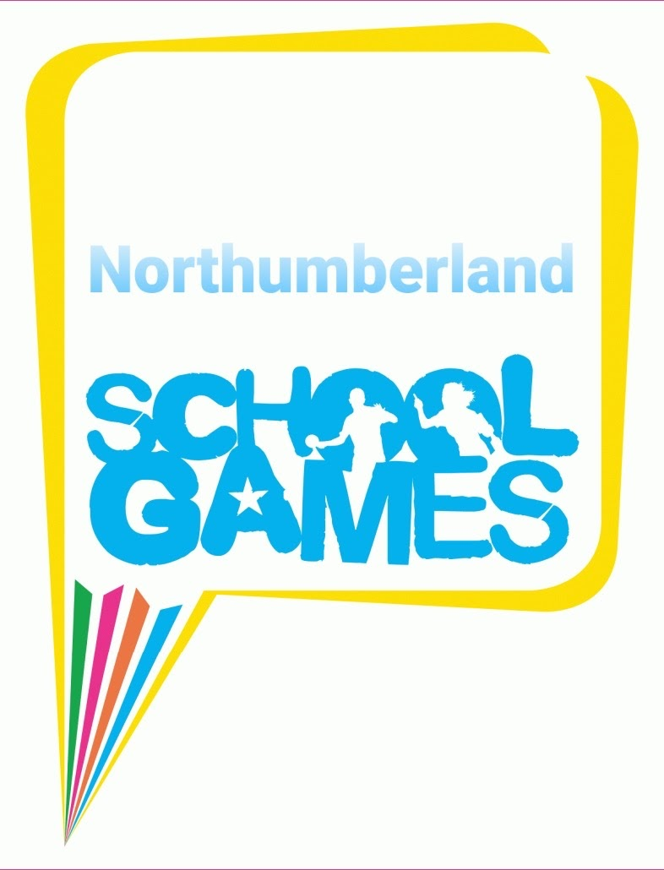

 | Access | Belong | Compete | Develop | Enrich
Pupil Target Group
Year 12 | Ultimate Frisbee | Secondary  Sports  Event  New Age Kurling  Boccia  Seated Volleyball  Athletics (festival) | Mixed Volleyball |  | Leadership
Year 10 | Mixed Rounders/ Cricket |  | Boys Table Tennis | Mixed Handball | Mixed Badminton - GCSE
 |  |  | Girls 7-side Rugby / Football (alternate years) |  | Secondary Problem Solving Challenge
Year 8 | Cricket |  | Sportshall Athletics | Basketball | This Girl Can  Trampolining
 | Rounders |  | Mixed Badminton | Handball
 | Softball |  | Girls' Netball
 |  |  | Boys' Football
Year 6 | Rugby League - touch? | Primary  Sports  Event  New Age Kurling  Boccia  Seated Volleyball  Athletics (festival) | Hockey | Tag Rugby | Orienteering
 | Dodgeball |  | Tag Rugby x 2 | Girls Football | Multi- Sport Festival - transition
 |  |  | Quad Kids
 |  |  | Girls' Netball
 |  |  | Sportshall Athletics
Year 4 | Tri-Golf |  | Tag Rugby | Gymnastics | Dodgeball
 |  |  | Quad Kids |  | Kwik Cricket
Gymnastics
(Area club team)

